Y1 Home Learning additional activities: Spring Term
Link to our history topic.  Create a secret message in morse code for the teachers to solve.  Or create your own code for us to crack! | Link to our science topic.  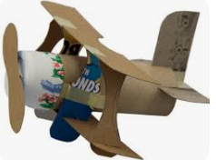  Make a model out of recycled materials. Can you name the materials you’ve used? | Link to physical education.  Try out a new sport or physical activity and send us a picture.  Hillsborough Park has lots of options including a Sunday morning junior parkrun and lots of activities (many free) at Courtside.  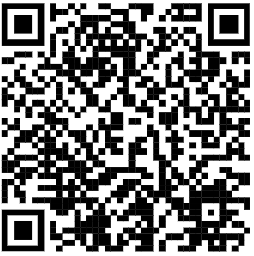  Link to junior  parkrun
Link to our maths.  Compare the length, weight and height of different objects around your house.  Can you compare up to 5 objects and put them in order.  Send us a picture that we can share with the class.  We will be learning about measure in Spring 2. | Speaking and listening and turn taking skills.  Play a board game with your family. Send a picture to class and then you do a show and tell all about how to play the game.  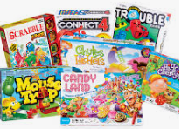 | Phonics learning.  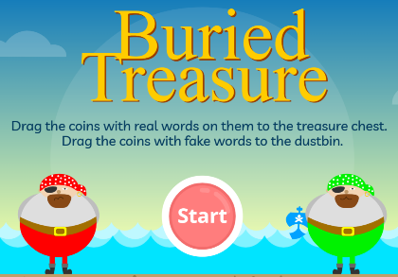  Use this QR code to play the on the phonics game buried treasure  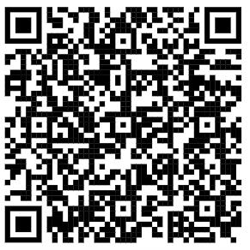
These are all optional activities, if they are completed they will all be given the time to present their work and share with the class.
The home learning expectations will be that the children will read 4 times and this will be checked in their reading records each Friday, and they will regularly practice counting forwards and backwards in 2s, 5s and 10s.

