Y1 Home Learning additional activities: Autumn Term
Create a picture timeline of photos from when you were a baby until now.  Remember to make sure it is in chronological order.  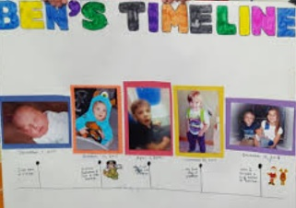 | Create a poster all about you.  What do you like doing?  What are your favourite foods?  Who is in your family?  Include anything at all you would like to tell us about yourself. | Draw or paint a picture that uses spirals.  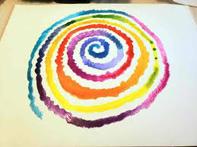
Learn one of the poems off by heart to perform to the class.  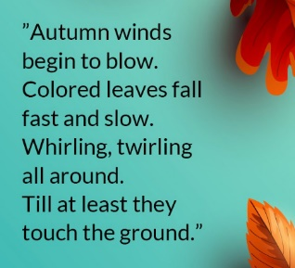 | 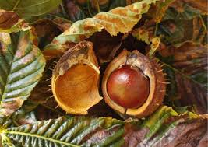  Go on a walk and spot signs of Autumn. Take pictures of what you find and send these to our Y1 email so we can show the class. | Make a model of an animal using any material you would like. Can you say if the animal is a mammal, amphibian, bird, fish or reptile?  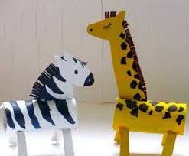
These are all optional activities, if they are completed they will all be given the time to present their work and share with the class.
The home learning expectations will be that the children will read 4 times and this will be checked in their reading records each Friday, and they will regularly practice counting forwards and backwards in 2s, 5s and 10s.



