Year Four Times Table Learning Menu – Autumn
Times Table Rockstars (TTRS)    Use your login from your journal on:  https://play.ttrockstars.com/auth  Use ‘Garage’ to work on the times tables set for you by your teacher – these should be the current ones you are working on. Use ‘Studio’ to practise a mixture of all times tables up to 12 x 12. | Practise with flashcards  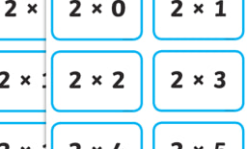  If you don’t have a set already, ask your adult at school for flashcards for the times table you are working on. You can swap them for another set when you have passed. You could even make your own!  - Use them on your own to practise  - Get someone at home to test you  - Time yourself to see how quickly you can answer all the questions | Using dice  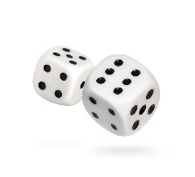  To practise any times table up to 6 x 6, roll two dice, or use https://www.random.org/dice/?num=2 if you don’t have dice at home. When you have rolled the dice multiply the two numbers together as quickly as possible.  To practise your specific times table:  - Roll two dice.  - Add them together.  - Multiply this number by your times table eg. 4
Draw a Waldorf Flower  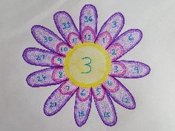  Create the picture above, it should have a centre circle, 12 petals around the centre, and then another 12 petals around the outer ring – one per inner petal.  The centre number is the times table you are practising and the inner petals are the different numbers you are multiplying it by 1 – 12: these can be in any order. Then, work out the answers! | Play Bingo  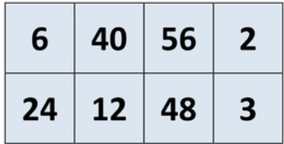  Make your own cards by using the backside of any paper to draw a 5×5 grid and filling in the boxes with the answers to your multiplication table, such as 16, 8, 48, 56, etc. Get someone at home to call out multiplication problems, for example: 6 x 8.  Calculate the answer, and if you have it on your grid then you can cross it out or cover it over. You can even play this game as a family or against your friends – in person or virtually. | Reinvent Games  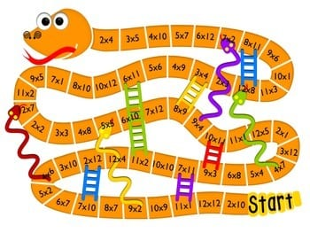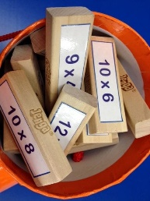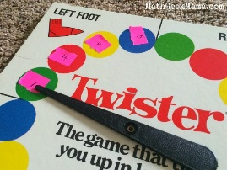  Turn your favourite games into a times table game! How about times table snakes and ladders, or Twister or Jenga!  Just add multiplication questions or numbers to your games – you can Google loads of ideas or even print ready made boards!
Each of the activities above should be repeated multiple times, not just once. Remember – the more you practise, the more confident you will become with your multiplication and division facts! To earn star stamps record the activities you are doing in your journal. Get a test regularly to see how you are doing!
By the Christmas holidays, we are aiming for as many children to have passed x10, x2, x5, x3, x4 and x8 times tables as possible.

