Year Four Home Learning Menu – Autumn
Geography Related Tasks | Research Tasks | Creative Tasks
Plan where you will put your Anglo-Saxon village: Below is a rough map of an area. Plan on where your settlement will go in order to be as useful as possible to the villagers.  The things you need as villagers are:  - Water for cooking and cleaning  - Wood for fires and building  - Higher land to see if any enemies are coming  - Land to grow crops on and space to keep animals  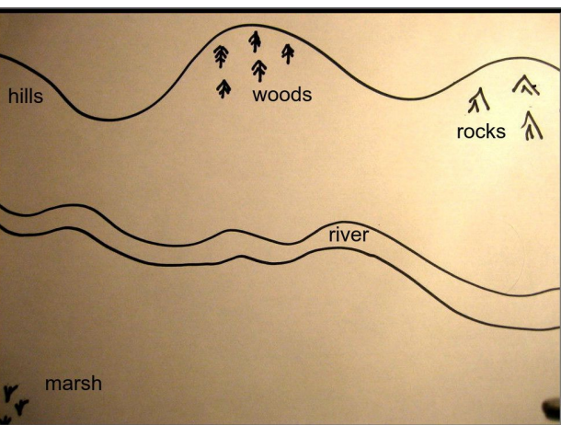 | Find out facts about the Anglo-Saxon’s daily life: Find as many facts as you can about what the Anglo-Saxon’s do during a normal day.  Present this learning in some way:  - A fact file  - A poster  - Creating a quiz | Build an Anglo-Saxon house: These were typically made from wood for the hut structure and thatched straw for the roof. They only had one room inside.  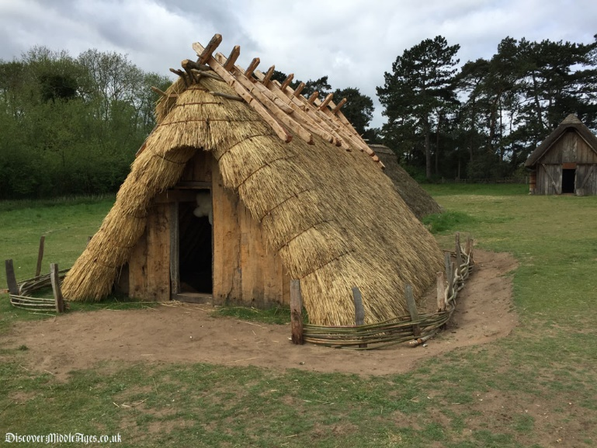
Draw a plan of the inside of an Anglo-Saxon house: The inside of the houses were one room where they slept, ate and cooked.  You will need to plan a space:  - To put the fire (a hole was put in most rooves for the smoke to escape)  - A space for sleeping on straw beds  - Benches to sit on  - To think about that the only light came from the open door and slits in the walls. | Create a job description/ advert for Anglo-Saxon jobs: Children as young as 10 had to do jobs or they would be punished. Choose one of the jobs they had to do and make it into a job advert. Here is a suggestion of categories you could use to help you describe it.  Job Title:  Main tasks:  Time of day to do it:  How this helped their village: | Create and design a warrior’s Anglo-Saxon shield: They were circular and made of wooden planks, and had an iron boss in the centre (a metal curved solid object). The colours of the shield are relevant to the owner of it.  blue - truth and strength  purple - majestic and royalty  green - joy, happiness and health  black - wisdom or grief  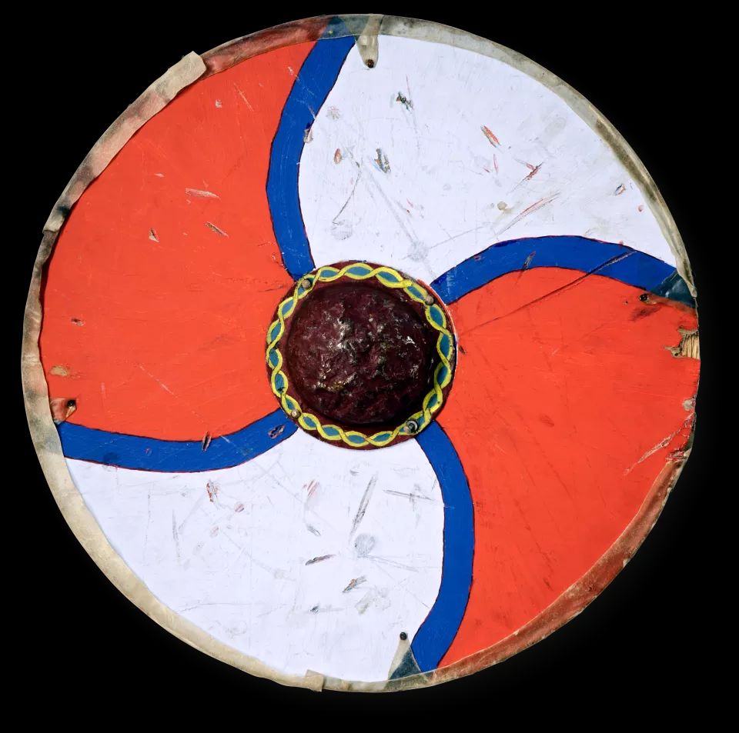
We are looking for high-quality home learning, so it may be that some of these tasks take more than one week to complete. We look forward to seeing the finished products!

Daily Home Learning Tasks: Reading (4+ reads per week), learning spellings (these will change bi-weekly), revising your CLIC gap (sent home on a Friday)

